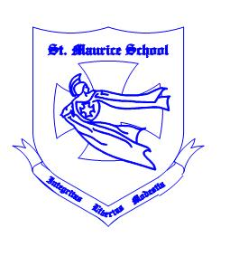**St. Maurice Daycare**

**School Age Program**

**2020/2021**

**Closures**

**September 7, 2020 (Labour Day) C:\Users\sbader\AppData\Local\Microsoft\Windows\Temporary Internet Files\Content.IE5\J5HOJ3WM\MC900445830[1].wmf**

**October 12, 2020 (Thanksgiving Day)**

**November 11, 2020 (Remembrance Day)**

**November 16, 2020 (CLOSED)**

**December 24, 2020 (Early Closure at 1:00 PM)**

**December 25, 2020 (Christmas Day)**

**December 28, 2020 (Boxing Day)**

**December 31, 2020 (Early Closure at 4:00 PM)**

**January 1, 2021 (New Years Day)**

**C:\Users\sbader\AppData\Local\Microsoft\Windows\Temporary Internet Files\Content.IE5\Z5IDSQOI\MC900415368[1].wmfFebruary 15, 2021 (Louis Riel Day)**

**February 22, 2021 (Closed)**

**C:\Users\sbader\AppData\Local\Microsoft\Windows\Temporary Internet Files\Content.IE5\J5HOJ3WM\MC900361798[1].wmfApril 2, 2021 (Good Friday)**

**May 24, 2021 (Victoria Day)**

**June 14, 2021 (CLOSED)**

**C:\Users\sbader\AppData\Local\Microsoft\Windows\Temporary Internet Files\Content.IE5\J5HOJ3WM\MC900338356[1].wmfJuly 1, 2021 (Canada Day)**

**August 2, 2021 (Civic Holiday)**